**MONTFORD FOOTBALL PROGRAM**

**“SWEET 16” SUMMER CONDITIONING**

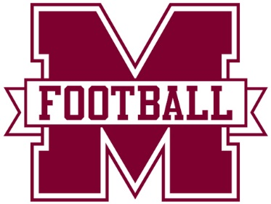

**All workouts are voluntary. Participation in summer workouts does not guarantee *any* player with a spot on the final fall roster. *All players* must participate in fall tryouts prior to school starting to earn a spot on the team.**

**_______________________________________________________________**

**WHO:** All rising 6th, 7th & 8th grade students zoned for Montford Middle School interested in trying out for the Montford Football Team in 2024. Homeschool students are welcome once their paperwork has been submitted to the Homeschool office.

**WHAT:** Weight lifting and conditioning sessions to prepare for upcoming fall football tryouts.

**WHERE:** Montford gym weight room and football fields**.**

**WHEN:** Monday, Tuesday & Thursday mornings from 8:30am- 10:15 am throughout June & July, (dates below.). Students should arrive no earlier than 8:15am and be picked up no later than 10:30am.

**HOW:** Workouts that include lifts and conditioning. Supervised instruction will be provided to teach proper form and safety on basic weight lifting movements that develop total body strength & power. Agility field drills that develop specific conditioning components will be at the core of the program.

**WHY:** To put each potential team member in the best possible physical and mental shape for tryouts.

**WORKOUT DATES:**

**Week 1:** June 18 & 20 **Week 4:** July 8,9 & 11 **Week 2**: June 25 & 27 **Week 5:** July 15, 16 & 18 **Week 3:** July 2,3 (Holiday change)

**ELIGIBILTY**: *All players are required by Leon County Schools to have a current physical, activity participation form and HIPPA form are all required* ***BEFORE*** *a student may participate*.

Forms can be found on the Montford Athletics/Football website. Paperwork should be *scanned* and emailed to [mmsathletics@leonschools.net](mailto:mmsathletics@leonschools.net).

**DRESS:** Athletic shorts, t-shirt, tennis shoes, cleats and a personal water bottle are required at each practice. Water and ice will be provided by the program.